TECHNICAL TIPS – “Wench With a Wrench”
By Gail Wagner – Midstate Miata Club of NY
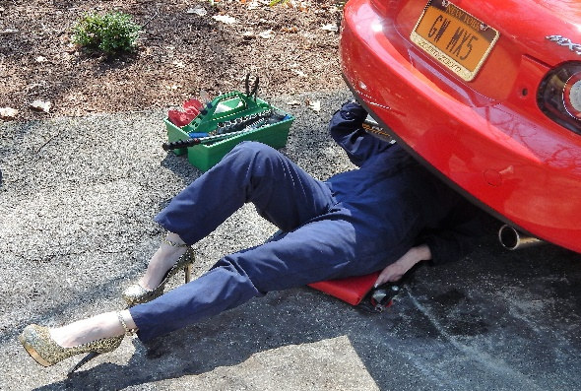
Hi, Miata Folks,
Yes, that’s me under there in my “work stilettos”.
I imagine like me many of you have gotten your Miatas back on the road for the summer 2017 driving season. I hope you have read my last article “Taking Your Miata Out of Storage” for some helpful suggestions or see “Tech” on our webpage www.midstatemiata.net. You might also find “Washing Your Car” (per Gail’s OCD tendencies) helpful as well.
I recently had an very interesting project assisting a fellow Club member trying to find an obsolete ”no longer available” Mazda Miata part for his 1996 Base model. The part in question was a “Safety Assist System” air bag controller an under-dash unit about the size of a small CD player that communicates to your air bags. Its apparent failure caused his airbag dash warning light to glow continuously.
As you may know, auto manufacturers are only required by law to carry parts for a minimum of 10 years after the model year if they so choose and this rather costly $600+ retail item had been discontinued??? and was no longer available.
His local Mazda dealer (who shall remain nameless) advised him that the part was no longer available and that it was illegal to purchase and install a used air bag part in NYS. What to do now?
Ah, an interesting project for me, a former college purchasing manager:
After scouring the Internet for an OEM original unsuccessfully, I called another northern local Mazda dealer that I had heard many positive reports and talked to their parts person who was unbelievably accommodating. He called his Mazda corporate contact and found out that while the part was no longer available in North American it was STILL available in Japan! Go figure….
With some finagling on the part of the dealer, Mazda Japan, a good chuck of change for the part, and $100 for expedited 2-week shipping (rather than normal 8-10 weeks, our entire driving season), it was possible to obtain the part.
I mention this incident because many of you have older model Miatas and this might be of interest especially if you have this problem OR find a needed part is no longer available OEM new, not legal used, or not available in the aftermarket.
Needless to say I was incredibly impressed with the customer service aspect of the dealer’s part person working with me to find a solution and I will certainly write a note of thanks to the dealership on his behalf.
Zoom Zoom Safely!
Gail

DISCLAIMER
Please note these tips are not reviewed or approved by the Mazda Motor Corporation or any other corporation or entity other than the originator. The Midstate Miata Club of NY does not accept any liability for damage or injury as a result of utilizing these tips and pointers. Please use common sense and always remember safety first!

